Lab 5: Adversarial Search - Minimax and Alpha-Beta Pruning
Rasikh Ali | ID: 42365 | CAI601400 Artificial Intelligence Lab Manual
1. Objective
To apply Minimax and Alpha-Beta pruning to a game tree, count the leaf nodes evaluated by each algorithm, and show that pruning reduces the search while preserving the Minimax decision.
2. Case Study
Choose the best move in a small two-player zero-sum game tree whose terminal scores are known. The tree is a complete binary tree of depth 3 with 8 leaves. The root is a MAX node, level 1 is MIN, level 2 is MAX, and level 3 holds the leaf utilities.
3. Source Code
import math

# Minimax with leaf-evaluation counter
def minimax(depth, index, max_turn, scores, target, counter):
# Base case: a leaf has been reached, so return its utility
if depth == target:
counter[0] += 1
return scores[index]

# MAX layer: choose the child with the highest value
if max_turn:
return max(
minimax(depth + 1, index * 2, False, scores, target, counter),
minimax(depth + 1, index * 2 + 1, False, scores, target, counter),
)

# MIN layer: choose the child with the lowest value
return min(
minimax(depth + 1, index * 2, True, scores, target, counter),
minimax(depth + 1, index * 2 + 1, True, scores, target, counter),
)

# Alpha-Beta pruning with leaf-evaluation counter
def alphabeta(depth, index, max_turn, scores, target, alpha, beta, counter):
if depth == target:
counter[0] += 1
return scores[index]

if max_turn:
value = float('-inf')
for i in range(2):
value = max(value, alphabeta(depth + 1, index * 2 + i, False,
scores, target, alpha, beta, counter))
alpha = max(alpha, value) # update MAX's guaranteed bound
if alpha >= beta: # pruning condition
break
return value

value = float('inf')
for i in range(2):
value = min(value, alphabeta(depth + 1, index * 2 + i, True,
scores, target, alpha, beta, counter))
beta = min(beta, value) # update MIN's guaranteed bound
if alpha >= beta: # pruning condition
break
return value

# Run both algorithms on the same tree and compare
def compare(name, scores):
scores = list(scores)
depth = math.ceil(math.log2(len(scores)))
scores += [0] * (2 ** depth - len(scores)) # pad to a complete binary tree

mm_leaves, ab_leaves = [0], [0]
mm = minimax(0, 0, True, scores, depth, mm_leaves)
ab = alphabeta(0, 0, True, scores, depth, float('-inf'), float('inf'), ab_leaves)

print(f"{name:<22} scores={scores}")
print(f"{'':<22} Minimax value={mm}, leaves={mm_leaves[0]} | "
f"AlphaBeta value={ab}, leaves={ab_leaves[0]} | Same? {mm == ab}\n")

if __name__ == "__main__":
compare("5.1 supplied tree", [3, 5, 2, 9, 0, 7])
compare("5.2 supplied tree", [3, 5, 2, 9, 3, 5, 2, 9])
compare("Reorder 1", [9, 5, 3, 2, 9, 5, 3, 2])
compare("Reorder 2", [2, 3, 5, 9, 2, 3, 5, 9])
compare("Edge: all equal", [4, 4, 4, 4, 4, 4, 4, 4])
4. Program Output
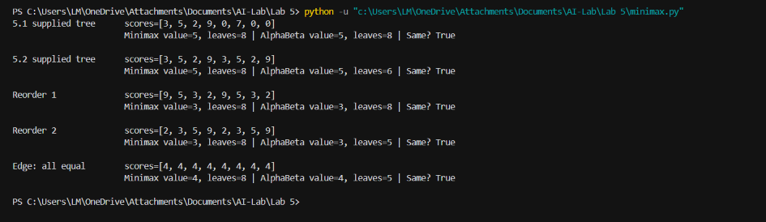
Summary of the output:
- 5.1 supplied tree: Minimax = 5 (8 leaves), Alpha-Beta = 5 (8 leaves)
- 5.2 supplied tree: Minimax = 5 (8 leaves), Alpha-Beta = 5 (6 leaves)
- Reorder 1: Minimax = 3 (8 leaves), Alpha-Beta = 3 (8 leaves)
- Reorder 2: Minimax = 3 (8 leaves), Alpha-Beta = 3 (5 leaves)
- Edge case, all leaves equal: Minimax = 4 (8 leaves), Alpha-Beta = 4 (5 leaves)
5. Lab Task 1: Hand Trace Using Minimax
Tree 1 (code 5.1): scores [3, 5, 2, 9, 0, 7] are padded with two zeros to [3, 5, 2, 9, 0, 7, 0, 0].
- Level 2 (MAX): A = max(3, 5) = 5, B = max(2, 9) = 9, C = max(0, 7) = 7, D = max(0, 0) = 0
- Level 1 (MIN): E = min(5, 9) = 5, F = min(7, 0) = 0
- Level 0 (MAX): Root = max(5, 0) = 5
Optimal value = 5. MAX should choose the left move.
Tree 2 (code 5.2): scores [3, 5, 2, 9, 3, 5, 2, 9].
- Level 2 (MAX): A = 5, B = 9, C = 5, D = 9
- Level 1 (MIN): E = min(5, 9) = 5, F = min(5, 9) = 5
- Level 0 (MAX): Root = max(5, 5) = 5
Optimal value = 5. Both moves tie, and the code selects the left one.
Handwritten trace:
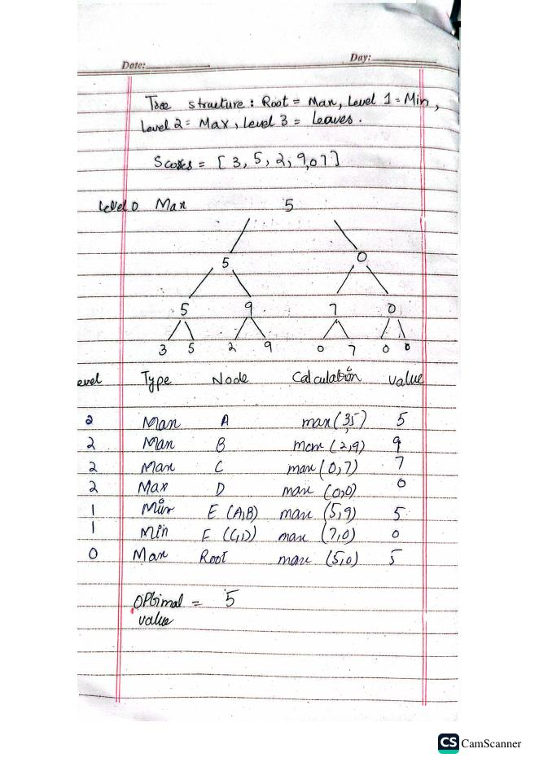
6. Alpha-Beta Hand Trace (Tree 2)
Initially alpha = -infinity and beta = +infinity. A branch is pruned when alpha >= beta.
- A (MAX), (alpha, beta) = (-inf, +inf): max(3, 5) = 5
- B (MAX), (-inf, 5): leaf 2, then leaf 9 gives alpha = 9, which is >= 5, but no leaf is left. Value = 9
- E (MIN): min(5, 9) = 5
- C (MAX), (5, +inf): max(3, 5) = 5
- F (MIN): beta = 5, so (alpha, beta) = (5, 5) and alpha >= beta. Node D is pruned (leaves 2 and 9 are skipped)
- Root (MAX): max(5, 5) = 5
Result: optimal value = 5, with 6 leaves evaluated and 2 leaves pruned. Plain Minimax evaluates all 8 leaves.
Reason for pruning: the root already has 5 guaranteed from the left subtree. After C returns 5, node F (a MIN node) can only be 5 or lower, so the right subtree can never beat 5 and node D does not need to be checked.
Tree 1 (code 5.1): no pruning occurs, so both algorithms evaluate 8 leaves, which matches the program output.
Handwritten trace:
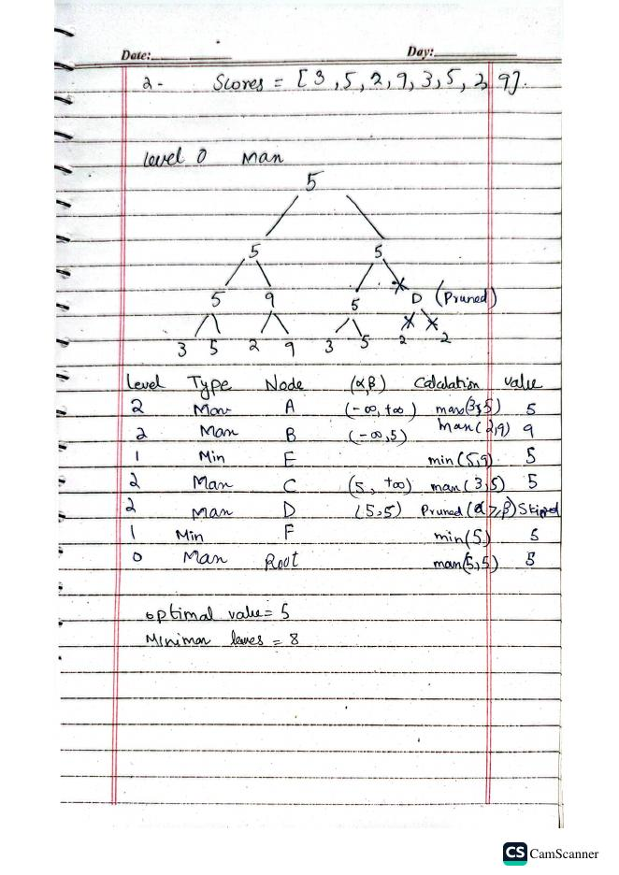
7. Lab Tasks 2 and 3: Leaf Counter and Reordering
A leaf counter was added to both algorithms (Task 2). The leaves were then reordered while the tree shape stayed the same (Task 3).
- Original [3, 5, 2, 9, 3, 5, 2, 9]: Minimax 8 leaves, Alpha-Beta 6 leaves, value 5 in both
- Reorder 1 [9, 5, 3, 2, 9, 5, 3, 2]: Minimax 8 leaves, Alpha-Beta 8 leaves, value 3 in both
- Reorder 2 [2, 3, 5, 9, 2, 3, 5, 9]: Minimax 8 leaves, Alpha-Beta 5 leaves, value 3 in both
Reorder 1 trace: A = 9, B = 3, E = 3; C = 9, D = 3, F = 3; Root = 3. In every MIN node the smaller child comes second, so no cut-off happens before the last leaf and all 8 leaves are evaluated.
Reorder 2 trace: A = 3, so beta of E = 3. At B the first leaf is 5, so alpha = 5 >= 3 and the leaf 9 is pruned. The root gets alpha = 3. C = 3 makes beta of F = 3, so alpha >= beta and D (two leaves) is pruned. Evaluated = 5, pruned = 3.
Observation: for each ordering, Minimax and Alpha-Beta return the same value. Only the number of evaluated leaves depends on the ordering.
8. Edge Case and Limitations
Edge case (all leaves equal, [4, 4, 4, 4, 4, 4, 4, 4]): both algorithms return 4. Alpha-Beta evaluates 5 leaves, because the condition alpha >= beta is also true for equal values, so ties cause pruning.
- Padding with zeros (code 5.1) is not neutral. The padded zeros are treated as real utilities, so a tree with negative utilities could return a different root value after padding.
- The code assumes a complete binary tree.
- Alpha-Beta only saves work when the ordering is favourable. In Reorder 1 it evaluates the same number of leaves as Minimax.
- During testing, the first version of the file failed because the import line and the minimax function were missing. Restoring the full code fixed the problem.
9. Interpretation of Results
In all five tests Minimax and Alpha-Beta returned the same root value, so pruning does not change the Minimax decision. Alpha-Beta never evaluated more leaves than Minimax (8, 6, 8, 5 and 5 leaves against 8 for Minimax). The saving depends on move ordering: none for Reorder 1 and the largest (3 of 8 leaves) for Reorder 2. Good move ordering therefore matters in real game-playing agents.
10. Viva-Ready Explanation of Design Choices
- Why does MAX assume MIN plays the worst outcome for MAX? In a zero-sum game MIN's gain is MAX's loss, so an optimal opponent picks the lowest value for MAX.
- What do alpha and beta represent? Alpha is the best value MAX can guarantee so far, and beta is the best value MIN can guarantee so far.
- Does pruning change the Minimax result? No. Pruned branches cannot influence the root value, and the tests confirm this.
- Why does move ordering matter? If the best moves are examined first, the bounds tighten early and more siblings are cut off. It changes the work done, not the result.
- Why is the counter a one-element list? A list is mutable, so all recursive calls update the same counter without a global variable.
- Why use alpha >= beta and not alpha > beta? Equal bounds mean the remaining children cannot improve the result, so they can be skipped safely.
11. Reflection
- What did I learn today? Alpha-Beta gives the same decision as Minimax with equal or fewer leaf evaluations, and I learned how alpha and beta are passed down and updated.
- How will I apply this in a real AI system? In turn-based game agents such as chess or tic-tac-toe, with a depth limit, an evaluation function and good move ordering.
- What failed or surprised me? The first run failed because part of the code was missing. I was also surprised that tree 5.1 had no pruning at all, while a reordering saved up to 3 leaves.
- What would I do differently next time? Test more orderings automatically and avoid zero padding by building complete trees.
- Responsible practice: the tree, utilities, bounds and pruning decisions are all shown so another student can reproduce the chosen move, and every result was checked by matching the hand trace with the program output.
12. Conclusion
Minimax and Alpha-Beta were implemented and traced. Both return the same root value, while Alpha-Beta evaluated 6, 8, 5 and 5 leaves (against 8 for Minimax) depending on the ordering. This shows that pruning reduces search without changing the optimal decision.

